Research stage

I initially decided to start my research by looking into wellbeing apps. The first app I looked at was tackle your feelings. I liked the idea that people could log how they were feeling each day and be able to then track this progress. I plan to implement this into my app.Next app I looked at for inspiration was Insight timer. I liked the system where you view your progress as you worked. I decided to make a wellbeing app is for students to make schedule plans because as a student myself I understand how hard it is to maintain a schedule. They will be able to set goals of how much they work, sleep, exercise and track their mental health. It can track your steps and the speed of your running to reach new speed goals. You can pick how many hours of exercise you want to do in a week and the app allows you to track your progress towards this goal. You can also track your mental wellbeing and hours of sleep. If you forget to log your results into the app it gives you a reminder over the day to remember to log your information from the day. The system will provide you with a recommendation of what schedule leads to the most productive and happy day. I realised I need to implement a system that can not only help track your goals and then also be able to see your progress as you work towards these goals.

My system will meet the requirement by:

* Having an automated system that can track analogue (running speed) and digital (turning on tracking of running)
* The website will track information and store it on fire base
* The website will take your stats and then calculate an average of what schedule will produces the most productive day and tells you about its effect on your average mood
* The system will be able to track your general well-being and will be able to answer the what if questions:

**What if** I get more sleep will it increase my productivity?

My website will allow you to track how long your worked and how long you slept and then show the user what hours of sleep lead to the most productive day.

**What if** do more exercise how will it affect my mental wellbeing?

My website allows to track your mood and amount of exercise and then will show the user how their mood was affected by increase of exercise.

* My what if questions use 3 parameters being tracking mood(string), your hours of sleep(integer) and steps and speed while running and be able to then reiterate these results back to the user.
* Website will display graphically which will display your average mood, sleep, and work you are getting done which user can view.

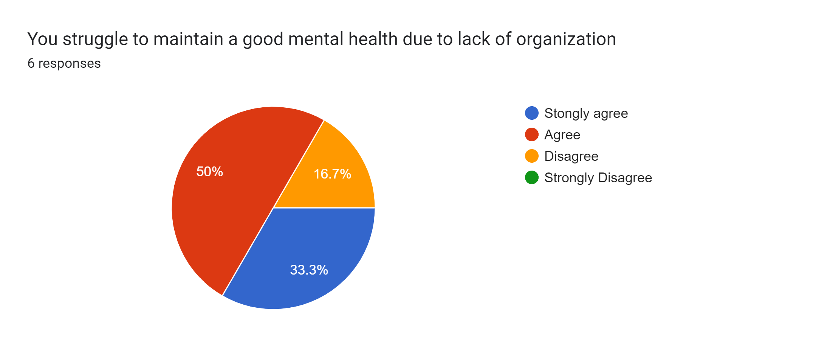

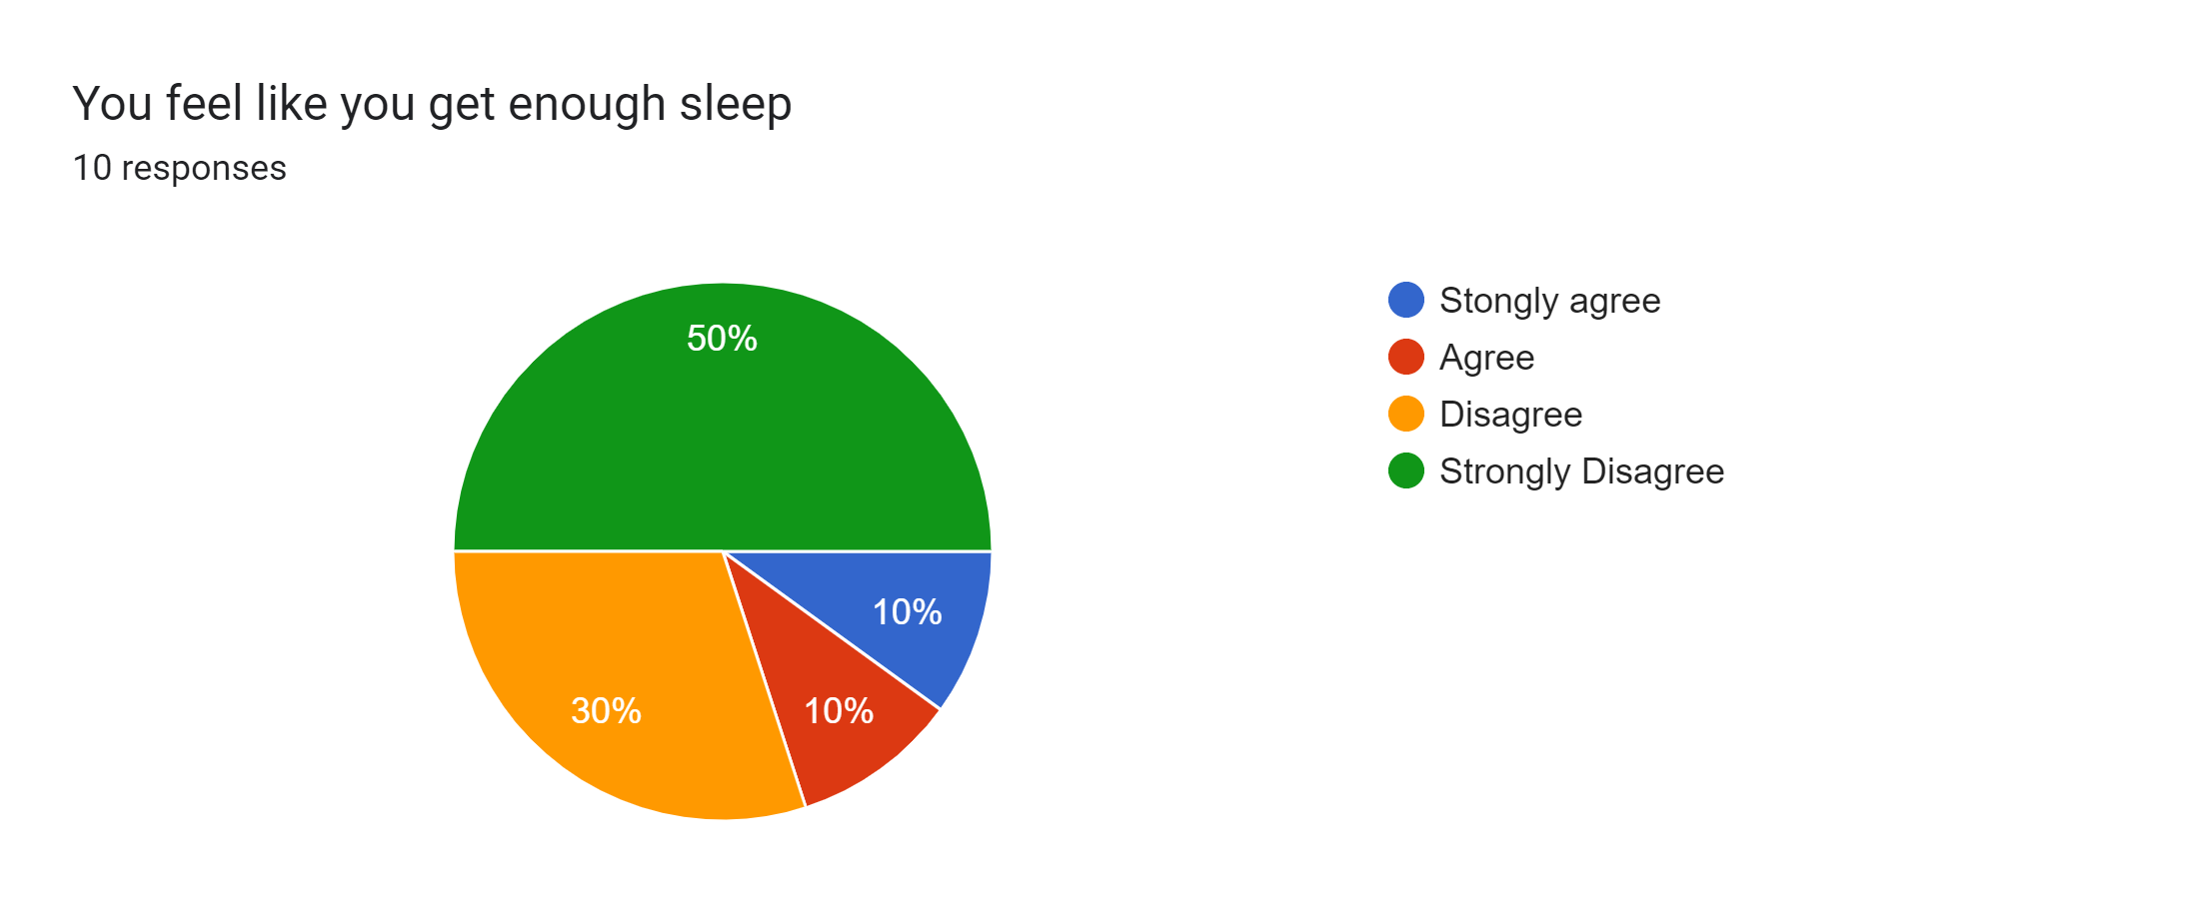

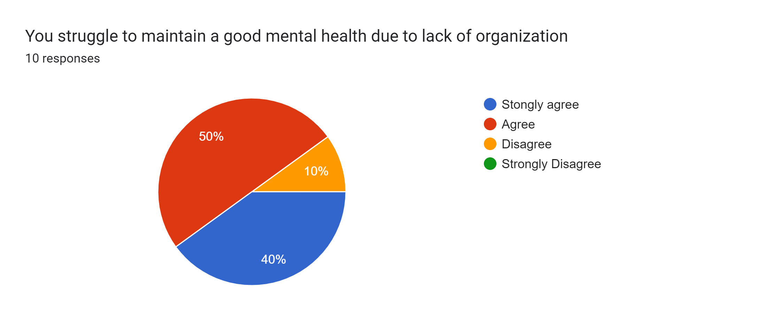b